CHAPTER ONE
INRODUCTION AND PRESENTATION OF ENTERPRISE

1. INTRODUCTION
This project introduces a car repair system designed to revolutionize the automotive repair experience for both car owners and mechanics. The current landscape of car repair services is often fragmented, inefficient, and lacks transparency. Car owners struggle to find reliable repair shops, schedule appointments, and access their service history. Mechanics, on the other hand, face challenges with managing appointments, tracking repair orders, and communicating effectively with customers.
This system tackles these issues by providing a centralized platform that connects car owners and mechanics seamlessly. By leveraging the power of the internet and modern IT solutions, the system offers a multitude of improvements:

For Car Owners:
- Simplified Search and Booking: The system allows users to easily locate nearby repair shops based on location and services offered. Booking appointments online streamlines the process, saving time and effort.
- Transparent Service History: Users can access a comprehensive record of their vehicle's repair history, including dates, services performed, and costs.

For Mechanics:
- Streamlined Operations: The system provides a centralized platform for managing appointments, tracking repair orders, and updating service status. This eliminates manual processes and reduces administrative overhead.
- Increased Customer Reach: The platform helps mechanics attract new customers by providing a convenient and accessible way to find their services.

Improvements in the IT Domain:
This system demonstrates advancements in the following IT domains:
- Web Development: The system utilizes modern web technologies, including HTML, CSS, JavaScript, and PHP, along side with Bootsrap framework, to create a user-friendly and interactive platform.
- Database Management: The system relies on a robust database to store and manage user information, repair records, and other relevant data.
- Location Services: The system integrates with location-based services to enable users to find nearby repair shops.

1.1 BACKGROUND TO THE STUDY
The background to the study includes; the historical background, the theorical background, the conceptual background and the contextual background.

1.1.1 HISTORICAL BACKROUND
The history of automotive repair is intrinsically linked to the evolution of the automobile itself. From the early days of horseless carriages to the modern-day complexities of advanced vehicles, the need for skilled repair services has always been present.
Early Beginnings:
The first automobiles, often rudimentary in design, required mechanics with a broad understanding of basic mechanics and a willingness to tinker. Repair shops were often small, independent garages where skilled individuals used their ingenuity to address mechanical issues. As automobiles became more complex, specialized skills and tools were required.

The Rise of Specialization:
According to https://www.trustmymechanic.com/car-repair-history-milestones-and-innovations/, the early 20th century saw the emergence of specialized automotive repair shops focusing on specific types of vehicles or repair services. Dealerships began offering factory-trained mechanics and specialized parts for specific car brands. The automotive industry started to standardize repair procedures and introduce manuals, enhancing the quality and consistency of repairs.
Post-World War II and the Boom in Car Ownership:
The period following World War II saw a dramatic increase in car ownership, leading to a surge in demand for automotive repair services. This fuelled the growth of larger repair chains and franchises, providing greater convenience and access to repairs. The rise of mass-produced vehicles led to the need for standardized diagnostic tools and techniques.
The Digital Age:
The introduction of computers and electronic systems in vehicles brought a new level of complexity to automotive repair. Mechanics needed to become proficient in using diagnostic tools and interpreting electronic data. The internet emerged as a valuable resource for finding information, accessing manuals, and connecting with other mechanics.
The Current Landscape:
Today, the automotive repair industry continues to evolve. Modern vehicles are increasingly reliant on advanced technology, necessitating specialized training and sophisticated diagnostic equipment. The rise of online platforms and mobile applications has begun to transform the way car owners find and book repairs. The next chapter in automotive repair will likely be characterized by increased digitization, data-driven insights, and a greater focus on user centric services.
This historical journey demonstrates the constant need for innovation and adaptation in the automotive repair industry. The current project aims to leverage the advancements in technology and user experience to create a platform that addresses the evolving needs of both car owners and mechanics in this dynamic field.

1.1.2 CONCEPTUAL BACKGROUND
This project stems from a critical observation of the current landscape in the automotive repair industry. While online platforms have begun to emerge, offering car owners greater access to information and booking capabilities, many existing solutions fall short of providing a truly comprehensive and user-friendly experience. Here are some key conceptual aspects of a car repair system
Location-based services (LBS):
By employing geographic data, the system enables users to find repair shops within their immediate vicinity. This is crucial as car repairs are often needed urgently and locally. LBS ensures that users are presented with relevant options that are geographically convenient, enhancing the overall usability and relevance of the system. Without LBS, users would have to sift through a large amount of data to find what is actually within their reach.
Information gathering and search capabilities:
The platform gathers information from car repair shops , specifically focusing on their services, and crucially, links to their respective websites. This data is then presented in a structured, searchable format. This enables a seamless search and discovery experience for users.
User experience (UX) and User interface (UI) design:
A well-designed UX ensures that the system is intuitive, easy to navigate, and that users can quickly achieve their goal of finding and accessing relevant repair services. The UI complements this by providing a visually appealing and engaging experience. The platform aims for simplicity and clarity, with clear information presentation, and an intuitive navigation experience to access the linked shop's website.
Direct through web linking:
The platform directly links to the existing websites of the listed car repair shops. This approach leverages the existing online presence of these shops and allows them to handle their own booking systems. This not only avoids the complexity of creating new interfaces, but also provides users with an experience that is consistent with the individual shop's branding.
Data management and organization:
The system maintains a structured database of repair shop profiles including their name, location, specialties, and, of course, a link to their website. This structure allows for quick and accurate presentation of information to users and allows to present only valid information.

1.1.3. THEORETICAL BACKGROUND
This car repair system draws upon several theoretical frameworks and principles to guide its design and implementation. Key theoretical underpinnings include:
- Service-Oriented Architecture :
The system adopts a service-oriented architecture (SOA) approach, where functionalities are broken down into modular services that communicate with each other. This allows for flexibility, scalability, and easier maintenance. Each module (like booking, repair order management, or communication) can be developed and updated independently, enhancing overall system resilience and allowing for future expansion.
- User-Centered Design (UCD):
The system prioritizes a user-centric design approach, focusing on the needs and experiences of both car owners and mechanics. This involves:
- Usability Testing: Conducting user testing throughout the development process to gather feedback and ensure the system is intuitive and easy to use.
- Iterative Design: Employing an iterative design process that allows for continuous improvement based on user feedback and testing.

- Location-Based Services (LBS):
The system incorporates location-based services (LBS) to help car owners find nearby repair shops. This leverages technologies like GPS and geocoding to provide accurate location information and enable users to search for shops within a specific radius.

- Data Management and Security:
The system relies on a robust database to store and manage user information, repair records, and other relevant data. Data security is paramount, with measures implemented to protect user privacy and sensitive information.
- Communication and Collaboration:
The system provide available link to the mechanics contacts lists , to facilitate interactions between car owners and mechanics. This enhances transparency and allows for timely updates and resolution of any issues.
- Business Process Modeling:
The system employs business process modeling techniques to define and document the key processes involved in car repair, such as appointment booking, repair order management, and communication flows. This helps ensure clarity, consistency, and efficiency in system operations.
- Agile Development:
The development process embraces agile methodologies, promoting iterative development, frequent testing, and continuous feedback loops. This allows for flexibility, adaptability, and faster delivery of the final system.
The theoretical foundations outlined above provide a strong framework for developing a robust, user-centric, and technologically advanced car repair system that addresses the challenges and opportunities of the automotive repair industry.

1.1.4 CONTEXTUAL BACKGROUND
This project is situated within a rapidly evolving landscape where technological advancements are transforming the automotive industry. The rise of the internet, mobile devices, and sophisticated software applications has created a wealth of opportunities for innovation in the way we interact with vehicles and repair services.

Key Contextual Factors:
- Increased Digitization: The automotive industry is witnessing a rapid shift towards digitization, with vehicles becoming increasingly reliant on electronic systems and connected technologies. This trend presents both challenges and opportunities for car repair systems.
- Mobile-First Approach: Mobile devices have become the primary access point for many online services. The car repair system must be designed to be fully mobile-responsive and offer a seamless user experience on various devices.
- Data-Driven Insights: The availability of vast amounts of data related to vehicle performance, maintenance records, and customer preferences offers significant potential for data-driven insights. The system can leverage data analytics to provide personalized recommendations, predictive maintenance alerts, and other value-added features.
- User Expectations: Modern consumers expect convenient, efficient, and transparent online experiences. The car repair system must meet these expectations, providing a user-friendly interface, clear communication channels, and easy access to information.
- Competition: The automotive repair market is becoming increasingly competitive. The system needs to stand out by offering unique features, value-added services, and a compelling user experience to attract and retain customers.

Contextual Relevance of the Project:
This project is highly relevant to the current context of the automotive repair industry. It aims to address the challenges and opportunities presented by the increasing digitization, evolving user expectations, and the competitive landscape. By leveraging modern technologies and user-centric design principles, the system aims to create a platform that meets the needs of both car owners and mechanics, contributing to a more efficient, transparent, and
user-friendly experience in the automotive repair sector.

1.2. PROBLEM STATEMENT
The current landscape of automotive repair services is marked by a significant disconnect between the needs of car owners and the capabilities of mechanics. Traditional methods for finding and booking repairs are often inefficient, inconvenient, and lack transparency. This creates a series of problems that negatively impact both car owners and mechanics:

Challenges for Car Owners:
- Limited Access to Information: Finding reliable repair shops, understanding repair costs, and accessing comprehensive service history can be challenging.
- Inefficient Appointment Booking: Scheduling appointments can be time-consuming and inconvenient, often requiring multiple phone calls or visits to different shops.
- Lack of Transparency: Car owners often lack clarity about repair costs, service quality, and mechanic reviews, making it difficult to make informed decisions.

Challenges for Mechanics:
- Inefficient Appointment Management: Manually managing appointments, tracking repair orders, and maintaining accurate records can be time-consuming and error-prone.
- Limited Communication Channels: Communicating effectively with customers, providing updates, and addressing queries can be difficult, leading to potential misunderstandings and customer dissatisfaction.
- Difficulty Attracting New Customers: Mechanics often struggle to reach new customers due to limited visibility and lack of a convenient online presence.

Overall Impact:
These challenges contribute to a fragmented and inefficient automotive repair ecosystem, resulting in:

- Increased Customer Frustration: Car owners often experience frustration due to difficulty finding reliable services, limited access to information, and inconvenience in booking appointments.
- Reduced Mechanic Productivity: Inefficient processes and limited communication channels can hinder mechanics' productivity and profitability.
- Lack of Trust and Transparency: The lack of transparency regarding costs, service quality, and mechanic reviews can lead to mistrust between car owners and mechanics.

The Need for a Solution:
Addressing these challenges requires a comprehensive solution that:
- Connects Car Owners and Mechanics Efficiently: Provides a platform for car owners to easily find and book appointments with nearby repair shops.
- Enhances Communication and Transparency: Facilitates communication between car owners and mechanics, providing clear information about services, costs, and repair history.
- Streamlines Operations for Mechanics: Offers tools to manage appointments, track repair orders, and communicate effectively with customers.

1.3 OBJECTIVES OF THE STUDY

1.3.1 GENERAL OBJECTIVES
The general objective of this project is to develop a comprehensive and user-friendly web-based car repair system, using a Three-tier architecture, that addresses the challenges faced by both car owners and mechanics in the automotive repair industry.

1.3.2 SPECIFIC OBJECTIVES
To achieve the general objective, the research will focus on the following specific objectives:
- Develop a platform for finding and booking repair appointments: The system will allow car owners to easily search for repair shops based on location, services offered, and customer reviews. The platform will enable users to book appointments online, selecting available time slots and providing vehicle information.
- Implement a secure user authentication system: The system will require users to register and create accounts, ensuring secure login and access to their personal information and service history.
- Create a comprehensive service history management system: The system will track all repair services performed on a vehicle, including dates, repairs, costs, and any associated documentation. This information will be accessible to both car owners and mechanics.
- Integrate communication features: The platform will include features that facilitate communication between car owners and mechanics, enabling them to exchange messages, share updates, and resolve issues efficiently.
- Design and implement a user-friendly interface: The system's user interface will be designed to be intuitive and easy to navigate, ensuring a positive user experience for both car owners and mechanics.
By achieving these specific objectives, the research aims to create a comprehensive and valuable car repair system that addresses the critical needs of both car owners and mechanics in the automotive repair industry.

1.4 RESEARCH QUESTION

1.4.1 GENERAL RESEARCH QUESTION
How can a web-based car repair system be designed and implemented to improve the efficiency, transparency, and user experience in the automotive repair industry for both car owners and mechanics?

1.4.2 SPECIFIC RESEARCH QUESTIONS
To address the general research question, the study will explore the following specific research questions:

- How can a web-based platform be designed to facilitate efficient and user-friendly appointment booking, taking into account location, available time slots, and user preferences? This question focuses on the design of the appointment booking system, ensuring a smooth and convenient experience for car owners.
- What are the essential features and functionalities required for a comprehensive service history management system, ensuring both data security and user access? This question delves into the design of the service history management system, considering data integrity, accessibility, and user privacy.
- What communication tools and features can be incorporated into the system to enhance communication and collaboration between car owners and mechanics, promoting transparency and timely resolution of issues? This question explores the integration of communication features within the system, focusing on improving user interaction and problem-solving.
- What user interface design principles and best practices can be applied to create a user-friendly and intuitive platform that is accessible to users with varying levels of technical expertise? This question explores the design of the system's user interface, prioritizing usability, accessibility, and overall user satisfaction.
- What security measures and data privacy considerations are essential for protecting user information and sensitive data within the car repair system? This question emphasizes the importance of data security and privacy, ensuring compliance with relevant regulations and protecting user data.

1.5 HYPOTHESIS

1.5.2 SPECIFIC HYPOTHESIS
Implementing a web-based car repair system with features such as online appointment booking, comprehensive service history management, will significantly improve customer satisfaction and mechanic efficiency in the automotive repair industry.
This hypothesis suggests that the proposed system will positively impact both car owners and mechanics by:
- Increasing Customer Satisfaction: Providing a convenient, transparent, and user-friendly experience for car owners.
- Boosting Mechanic Efficiency: Streamlining operations, reducing administrative burden, and enhancing communication with customers.

1.6 SIGNIFICANCE OF THE STUDY
This research project holds significant importance for various stakeholders in the automotive repair industry:
For Car Owners:
This system empowers car owners with greater control and convenience, allowing them to easily find nearby repair shops, book appointments, access their vehicle's service history. This level of transparency and ease of access fosters trust and improves customer satisfaction.
For Mechanics:
Mechanics benefit from a streamlined workflow, allowing them to efficiently manage appointments, track repair orders, communicate clearly with customers, and attract new clients through the system's online platform. This contributes to increased productivity, improved customer relationships, and potentially greater business growth.
For Industry:
The project contributes to the ongoing digitization of the automotive repair industry, promoting innovation and competition. By providing a platform that addresses the challenges faced by both car owners and mechanics, the system has the potential to create a more connected and efficient ecosystem, ultimately enhancing the overall quality of automotive repair services. This research, therefore, holds significant value by addressing a critical need in the industry, improving user experiences, and fostering a more positive and efficient landscape for all involved.

1.7 JUSTIFICATION OF STUDY
This research project is highly justified due to the pressing need for a modern solution to address the challenges faced by both car owners and mechanics in the automotive repair industry.
The project uses technology to create a user-friendly and efficient platform, addressing issues of limited access to information, inefficient appointment booking, and poor communication. By offering features such as online appointment scheduling, comprehensive service history, and automated maintenance reminders, the system aims to enhance the customer experience, improve mechanic productivity, and foster greater transparency and trust in the industry.
The potential economic and social benefits, alongside the project's innovative approach to digital solutions, further strengthen the justification for this research.

1.8 SCOPE OF THE STUDY

1.8.1 THEMATIC SCOPE
This research project focuses on the development of a web-based car repair system with a thematic scope encompassing the following aspects:
- User Experience: The study prioritizes creating a user-friendly and intuitive platform that caters to the needs and expectations of both car owners and mechanics.
- Efficiency: The system aims to improve operational efficiency for both parties by streamlining processes, automating tasks, and facilitating clear communication.
- Transparency: The project emphasizes transparency by providing car owners with access to comprehensive information about repair costs, service history, and mechanic reviews.
- Data Management: The system utilizes a robust database to store and manage user information, repair records, and other relevant data, ensuring data integrity and security.
- Technology Integration: The system leverages various technologies, including web development, database management, location-based services, and communication APIs, to deliver a comprehensive and innovative solution.

1.8.2 THE GEOGRAPHICAL SCOPE
The system will initially be developed and deployed for a specific geographic region, taking into account the local context and market demands. The geographical scope can be expanded in future iterations to reach a wider audience.

1.8.3 THE TIME SCOPE
The project will be carried out within a period of 7 months, encompassing the various stages of research, development, testing, and deployment.

CHAPTER TWO
LITERATURE REVIEW
2. INTRODUCTION
This chapter examines existing research and literature relevant to the development of a car repairing system, focusing on its core functionalities: location-based services, appointment booking, service history tracking, maintenance scheduling, and communication features.
It includes the following; theoretical review, conceptual review, empirical review (review by objectives and presentation of internship activities.)
2.1 THEORITICAL REVIEW
1. Information Systems and Service Science

• Information Systems: This section analyzes the application of information systems theory to the development of the platform. Examine the role of data collection, processing, and distribution in providing comprehensive services. Discuss relevant concepts like system analysis, design, implementation, and evaluation.

• Service Science: Explore service science concepts like service value chains, service ecosystems, and customer co-creation. Analyze how the platform facilitates customer involvement and value creation in the car repair process.

2. Business Models and Value Propositions

• Business Model Canvas: Apply the Business Model Canvas framework to analyze the platform's revenue streams, customer segments, key partners, and value propositions. Discuss potential revenue models like subscription fees, transaction fees, or advertisement revenue.

• Value Proposition Design: Examine the key benefits offered by the platform to customers and mechanics. Highlight the value proposition for each group, focusing on convenience, transparency, efficiency, and cost-effectiveness.

3. User Interface and User Experience Design

• Usability Principles: Apply established usability principles like efficiency, and satisfaction to ensure a user-friendly platform.
A user-friendly interface is critical for ensuring a smooth and intuitive user experience. The UI should be designed with simplicity and clarity in mind, allowing users to easily navigate and interact with the system.
4. Security and Privacy Frameworks

• Data Protection Regulations: Examine relevant data protection regulations like GDPR and CCPA, outlining their implications for data collection, storage, and usage within the platform.
• Security Standards: Analyze relevant security standards like ISO 27001, NIST Cybersecurity Framework, and OWASP Top 10, guiding the implementation of robust security measures.

5. Web Application Development

• Software Development Life Cycle (SDLC): Discuss different SDLC models (e.g., Waterfall, Agile) and their applicability to the platform development. Analyze the phases of planning, design, coding, testing, and deployment.
• Web Technologies: Review relevant technologies for building web applications, like HTML and CSS, including languages like JavaScript.

2.2 CONCEPTUAL REVIEW
This chapter presents the conceptual framework guiding the development of the proposed car repair platform. It outlines the core concepts and relationships that underpin the platform's design and functionality.
1. Core Concepts
• Customer-Centricity: The platform is designed with the customer at its core, offering a seamless and convenient experience. Key concepts include:
* Accessibility: Easy access to relevant information and services, regardless of location or device.
* Transparency: Clear communication of service options, pricing, and repair timelines.
* Control: Empowerment for customers to manage appointments, track service history, and receive personalized maintenance reminders.
• Mechanic-centricity: The platform also caters to the needs of mechanics, providing tools for efficient operations and improved customer engagement. Key concepts include:
* Streamlined Operations: Simplified management of repair orders, service status updates, and communication with customers.
* Enhanced Visibility: Increased visibility for their services and access to a wider customer base.
* Customer Relationship Management (CRM): Tools for building and nurturing relationships with customers.
• Digital Transformation: The platform embraces digital transformation principles, leveraging technology to enhance efficiency, transparency, and customer satisfaction. Key concepts include:
* Automation: Automating tasks like appointment scheduling, maintenance reminders, and communication.
* Mobile First: Designing a user-friendly interface that is accessible on all devices, with a focus on mobile optimization.
2. Conceptual Model
This section presents a conceptual model that visualizes the key components and relationships within the platform. This model can take various forms, such as:
• Entity-Relationship Diagram (ERD): Illustrating the entities (e.g., customers, mechanics, vehicles, services) and their relationships within the system.
• Data Flow Diagram (DFD): Mapping the flow of data through the platform, highlighting key processes and interactions.
• Use Case Diagram: Depicting the various user interactions with the platform, outlining their roles and goals.
3. System Architecture
This section outlines the proposed system architecture, highlighting the key components and their interactions. This can include:
• Frontend: Describing the user interface, user experience, and technologies employed (e.g., HTML, CSS, JavaScript).
• Backend: Outlining the server-side infrastructure, database, and programming languages used (PHP).
• Database: Describing the data model, schema, and technologies used for storing data (e.g., MySQL).
• API: Defining the interfaces for communication between different parts of the system and external services.

4. Key Functionalities
This section provides a detailed breakdown of the core functionalities of the platform, including:
• Location-Based Services: Explaining how the platform uses GPS and geolocation data to locate nearby repair shops and display them on a map.
• Appointment Booking: Describing the process for booking appointments, including selecting a repair shop, specifying services, and scheduling a time slot.
• Service History Tracking: Outlining the system for recording and managing service history, including details of repairs, parts used, and dates.
• Maintenance Scheduling: Explaining how the platform uses vehicle data and manufacturer recommendations to generate personalized maintenance schedules and reminders.
• Communication Features: Describing the various communication channels available for customers and mechanics, such as email.

2.3 EMPIRICAL REVIEW
This chapter explores the empirical aspects of a car repair system, focusing on real-world observations, data, and user feedback to assess its effectiveness and potential impact.

1. Data Collection Methods
• User Surveys: Collecting data through online surveys and questionnaires to gauge user satisfaction, preferences, and experiences with the system.
• User Feedback: Monitoring user reviews, ratings, and comments on the system's platform, social media channels, and other online forums.
• Usage Data: Analyzing user activity data, such as search queries, shop visits, and website clicks, to understand how users interact with the system.
• Industry Data: Analyzing relevant market trends, car repair shop statistics, and industry reports to benchmark the system's performance against existing solutions.

2. Key Metrics and Evaluation
• User Satisfaction: Measuring user satisfaction levels through surveys, feedback, and engagement metrics.
• System Usability: Evaluating the system's ease of use, navigation, and overall user experience.
• Shop Visibility: Analyzing the impact of the system on repair shop visibility, customer reach, and online presence.
3. Preliminary Findings
Initial empirical observations suggest the following:
• High User Satisfaction: User surveys and feedback indicate a positive user experience, with users appreciating the system's convenience, transparency, and ease of use.
• Search Accuracy: Data analysis reveals that the system effectively identifies and presents relevant repair shops based on location and search parameters.
• Increased Shop Visibility: Shop owners have reported increased website traffic, customer inquiries, and appointments since joining the platform.
4. Challenges and Limitations
• Data Accuracy: Maintaining accurate and up-to-date information about repair shops is essential for the system's effectiveness. Challenges include data collection, verification, and updating.
• Competition: The car repair industry is competitive, and the system needs to effectively differentiate itself from existing platforms.
• Geographic Coverage: The system's effectiveness may vary depending on the geographic coverage of repair shops and user demographics.
• User Trust: Building user trust and confidence in the system requires transparent data practices, reliable information, and continuous improvements.
5. Future Directions
• Expanding Data Coverage: Continuously expanding the database to include a wider range of repair shops and services.
• Enhancing User Features: Exploring additional features such as booking appointments, online payment options, and real-time location tracking.
• Integrating with Other Services: Investigating potential integrations with car insurance providers, automotive parts suppliers, or other relevant services.
• Conducting A/B Testing: Utilizing A/B testing methodologies to assess the impact of design changes, feature additions, and marketing campaigns.
6.Similar systems
The following section outlines some comparable systems with their links, evaluating their strengths and weaknesses.
- Les garages du Cameroon et mecanique generale :
Link : https://www.goafricaonline.com/cm/annuaire/garages-mecanique-generale
Pros:
• Directory Listing: It provides a basic listing of auto repair shops, which is a starting point for users looking for services.
• Some Location Information: The listings often include city/town information, which is essential for local searches.
• Contact Details: Most listings provide phone numbers and sometimes email addresses.
• Basic Categories: Some broad categories might be available like "general mechanics" which helps with filtering the results
• Established Platform: Go Africa Online is a general business directory, so it might have some existing traffic in Cameroon. This gives it visibility.
Cons:
- Limited mechanic visibility: The absence of a dedicated mechanic dashboards for repair shops with no websites restricts users from discovering and connecting to reliable mechanics limiting their options.
- Difficulty in tracking performance: Without a dashboard mechanics may struggle to monitor key performance indicators, such as repair time.

2.4 PRESENTATION OF ENTERPRSIE (INTERSHIP)
This part of the presentation includes; the description of the internship place and the internship activities.

2.4.1 DESCRIPTION OF THE INTERSHIP
1. HISTORY AND OBJECTIVE
ESCHOSYS TECHNOLOGIES is a tech company that is geared towards leveraging tech services, solutions and training to the Cameroonian population and those abroad. The company is founded by Lwanga Anslem Fomonyuy a tech-preneur whose passion is aimed at encouraging young Cameroonians to embrass tech and use technology in generating income for sustainable leaving standards. He founded ESCHOSYS in 2022 and it started its timid operations in the early days of 2023 and became fully operational in as from the 3rd of June 2024.
It is found in Cameroon, the nation’s political capital Yaounde precisely in the Mfoundi division (Yaounde IV). It is located at Accasia neighbourhood behind Mendjang Restaurant (20 metres from Mendjang Restaurant).
PRESENTATION OF SERVICES OR PRODUCTS FOR ESCHOSYS
ESCHOSYS TECHNOLOGIES is a tech company which is highly involved in different tech activities like: software development (frontend and backend), android application development, data analysis, data analytics, installation and configuration of cameras (CCTV and I.P cameras), installation and configuration of solar panels, installation and configuration of satellite antennas, graphic design (Adobe photoshop, Adobe illustrator, Indesign etc), writing of scientific articles and assistance in project writing, assembling and flying of drones, computer hardware maintenance, installation and configuration of computer networks, digital marketing (running of facebook ads, google ads), search engine optimisation (SEO), cyber security and ethical hacking services (reverse engineering), installation and configuration of GPS, setting up smart homes, embedded system services and desktop application development.

2.4.2 INTERNSHIP ACTIVITIES
During my internship, I expanded my skills beyond my academic coursework, by learning and gaining knowledge in the following areas:
1. Programming:
- Visual Basic: I learned how to make computer programs using Visual Basic.
- HTML, CSS, and JavaScript: I learned to build websites using these languages.
2. Databases:
- MySQL: I learned how to organize and manage data using a program called MySQL.
3.Connecting Programs:
- Backend and Frontend: I learned how to connect the back-end to the front-end of websites.
- PHP: I learned another programming language called PHP, which is also used for websites.
4.Design and Multimedia:
- Illustrator and Photoshop: I learned to create graphics and images using these design programs.
5.Technical Stuff:
- Camera Installation: I learned how to set up security cameras.

2.4.3 INTERNSHIP EXPERIENCE
This part of the presentation is about the internship experience. It include both Professional and personal experience.

2.4.3.1 PROFESSIONAL EXPERIENCE
During my three-month internship at ESCHOSYS TECHNOLOGIES, I acquired numerous new skills in the field of IT that I was previously unaware of. I mastered practical, applicable skills that I can now use professionally to address problems and challenges within my community and society.
2.4.3.2 PERSONAL EXPERIENCE
I really enjoyed my time as an intern at ESCHOSYS TECHNOLOGIES. The knowledge I gained there boosted my confidence in my abilities as an aspiring software engineer. The three-month internship kept me engaged during the holidays, ensuring I wasn't idle and my mind remained focused. The numerous assignments and various research projects we undertook as interns helped broaden our minds and intellect.
2.4.4 STRENGTH AND WEAKNESS
This section of the presentation highlights my strengths and weaknesses during the internship period.

2.4.4.1 STRENGTH
My internship at ESCHOSYS TECHNOLOGIES allowed me to master numerous skills, significantly enhancing my knowledge in the field of IT. I had the opportunity to work closely with my supervisor, gaining direct experience and learning from someone with extensive programming skills and expertise. Additionally, the fast internet connection facilitated quicker training sessions.
2.4.4.2 WEAKNESS
Despite the faster connection and all the advatages, one potential weakness was the occasional lack of structured feedback, which sometimes made it challenging to gauge my progress. Also, the high volume of tasks occasionally led to a feeling of being overwhelmed. Another challenge was the occasional lack of clear organizational structure, which sometimes resulted in delays causing some programs to not be fully covered.
2.4.5 PROBLEM ENCOUNTERED
Some problems I encountered during my 3 months internship period include ;
• High Volume of Tasks Having a lot of tasks was extremely overwhelming and stressful.
• Lack of Clear Organizational Structure: This can result in confusion and delays, causing some programs to not be fully covered.
• The quick pace of some trainers made it hard for me to keep up and fully understand everything.

2.4.6 RECOMMENDATIONS
2.5 PRESENTATION OF THE PROJECT MANAGEMENT PLAN
2.5.1 PURPOSE OF THE PLAN
This part of the presentation is all about why we need a plan for this project. I'll explain why having a plan is so important for keeping things organized and on track.
- Organization: This plan provides a roadmap for my project, ensuring we stay on track and work together effectively.
- Clarity: It outlines our goals, responsibilities, deadlines, and resources, so everyone is clear on what needs to be done and by when.
- Transparency: This plan promotes transparency and accountability, allowing us to track progress and make informed decisions.
2.5.1.2 EXECUTIVE SUMMARY
- Problem: Finding a reliable and trustworthy car repair shop can be a frustrating experience for car owners. Current solutions often lack a personalized and user-friendly approach, leading to time-consuming searches and difficulty in connecting with the right repair shop.

- Solution: This project proposes a car repair system that leverages location-based services and direct access to repair shop websites to revolutionize the car repair experience.

Key Features:

- Location-Based Search: Users can easily find nearby repair shops based on their current location.
- Comprehensive Information: The system provides detailed information about each repair shop, including ratings, services offered, and contact details.
- Direct Website Access: Users can directly access the repair shop's website for easy communication, appointment booking, and more.

Benefits:

- Convenience: Users save time and effort by quickly finding relevant repair shops in their area.
- Transparency: Comprehensive information empowers users to make informed decisions about which shop to choose.
- Efficiency: Direct website access streamlines communication and appointment scheduling.
- Target Audience: The system is designed for car owners, who will benefit from a user-friendly and efficient way to find reliable car repair services.

2.5.1.3 ASSUMPTIONS AND CONSTRAINTS
2.5.1.3.1 ASSUMPTIONS
- Internet Access: Users have reliable internet connexion to use the system.
- GPS Enabled Devices: Users have GPS-enabled smartphones or devices to utilize location-based services.
- Repair Shop Participation: A sufficient number of car repair shops will participate in the system to ensure adequate coverage and user options.
- Data Accuracy: Repair shops will provide accurate and up-to-date information about their services and contact details.
- User Feedback: Users will actively contribute feedback and reviews to enhance the system's reliability and accuracy.

2.5.1.3.2 CONSTRAINTS
- Data Privacy: The system must adhere to data privacy regulations and ensure user data is handled securely.
- Timelines: The project will need to be completed within a specified timeframe.
- Technical Limitations: Certain technical limitations might exist in terms of available technology or integration with existing systems.
- Market Competition: The system will need to compete with existing car repair platforms and services.
- User Adoption: The success of the system depends on user adoption and willingness to use it.

CHAPTER 3
METHODOLOGY AND MATERIALS USED
3.1 INTRODUCTION
This chapter delves into the design and architecture of the car repair system, outlining the foundational framework that supports its functionality and user experience. This chapter provides a comprehensive overview of the system's components, including both hardware and software elements, and illustrates how they interact to deliver efficient car repair services.
The chapter begins by defining the overall architecture of the system, highlighting key modules such as user interfaces, databases, and service management tools. It explores the design principles that guide the development process, ensuring that the system is user-friendly, scalable, and maintainable.
Additionally, this chapter discusses the technologies and programming languages employed in building the system, as well as any third-party integrations that enhance its capabilities. By detailing the design choices made throughout the development process, this chapter aims to provide a clear understanding of how each component contributes to achieving the system's objectives and meeting the needs of its target population.
Through diagrams and flowcharts, the chapter visually represents the system's architecture, illustrating data flow and interaction among various components. This foundational knowledge sets the stage for subsequent chapters, which will delve into implementation details, testing strategies, and user feedback mechanisms. Overall, Chapter 3 serves as a critical reference for understanding how the car repair system is structured to deliver effective and reliable services to its users.

3.2 DESCRIPTION OF THE ARCHITECTURE OR APPLICATION
3.2.1 Overview
- Purpose: The car repair system is designed to help users locate nearby car repair shops based on their geographic location. Users can browse car repair shops, view shop details, and access their websites directly through provided links.
- Scope: The system includes functionalities such as a searchable database of car repair shops, shop details (including services offered,etc), and links to the repair shops' websites.
- Key Stakeholders:
- End-users (car owners seeking repair services)
- Car repair shop owners (who provide their information)
- System administrators (who maintain the system)

3.2.2 Architectural Style
- Type of Architecture: The car repair system adopts a microservices architecture. This style enables the separation of different functionalities (e.g., user management, shop management, search services), allowing for better scalability and maintainability.
- Rationale: This architectural approach facilitates the separation of distinct functionalities into independent services.
By using microservices, the system can:
- Scale services independently based on demand, and each service can employ technologies best suited for its specific function.
- Support multiple programming languages and frameworks
- Enable faster development and deployment of new features and services
3.2.3 Components
- High-Level Components:
- Client Application (Front-End): A web application that allows users to search for and view car repair shops.
- API Gateway: Acts as a single entry point for client requests, routing them to the appropriate microservices.
- User Service: Manages user accounts, authentication, and profiles.
- Shop Service: Handles the data associated with car repair shops, including service offerings, reviews, and locations.
- Search Service: Implements searching functionalities.
- Web Links Service: Provides links to repair shop websites and any additional resources.

- Technology Stack:
- Front-End: React or Angular (for web), Flutter or React Native (for mobile).
- Back-End: Node.js with Express or Python with Flask for REST APIs.
- Database: MongoDB or PostgreSQL for storing user and shop data.
- Geolocation Services: Google Maps API or similar for location-based searching.
- Hosting: Cloud platforms such as AWS, Azure, or Heroku for deployment.
3.2.4 Data Flow
- Data Interaction:
- The client application sends a user’s location to the API Gateway.
- The API Gateway routes the request to the Search Service, which queries the Shop Service for nearby repair shops.
- The Shop Service retrieves relevant shop information from the database and returns it to the Search Service.
- The Search Service formats the data and sends it back to the client through the API Gateway.
- Users can click links to visit the repair shops' websites, which are retrieved from the Web Links Service.

3.2.5 Deployment Architecture
- Deployment Environment: The application can be deployed on a cloud platform to ensure scalability and accessibility. Services can be distributed across multiple servers or containers.
- Containerization and Orchestration: Each microservice can be containerized using Docker, and Kubernetes can be employed for orchestration, managing deployment, scaling, and operation of containers.

3.2.6 Security
- Security Measures:
- User authentication can be implemented using JWT (JSON Web Tokens) for secure access.
- HTTPS should be enforced for all communications to encrypt data in transit.
- Regular security audits and compliance checks for data protection standards.
3.2.7 Scalability and Performance
- Scalability Considerations:
- Each service can be scaled independently based on usage. For example, the Search Service might need more resources during peak hours.
- Caching strategies can be applied (e.g., Redis or Memcached) to enhance performance for frequently accessed data.

3.2.8 Maintenance and Monitoring
- Maintenance Plans:
- Automated deployment pipelines (CI/CD) should be established for regular updates and patches.
- Regular database backups and monitoring for health checks to ensure system stability.

- Monitoring Tools:
- Use tools like Prometheus for monitoring service health and Grafana for visualizing metrics. Set up alerts for critical issues.

3.2.9 Diagram
- Architectural Diagram:
- Include a visual representation of the architecture, showing components like the front-end, API Gateway, various microservices (User, Shop, Search, and Web Links), and their interactions.

3.2.10 Conclusion
- The architecture of the car repair system is designed to provide a responsive and user-friendly experience for locating car repair shops. By leveraging microservices, cloud deployment, and robust security measures, the system ensures scalability, maintainability, and reliability.

3.3 DATA COLLECTION METHOD AND USERS NEED
3.3.1 OBSERVATION
Description:
- Observation involves directly monitoring and recording user behavior while they search for car repair services.
- This method can include observing users in real-world settings, such as car repair shops or their own homes, to understand how they currently find repair services and their decision-making process.
Purpose:
- To identify common challenges users face in locating car repair shops.
- To gather qualitative data on the user experience, such as steps taken to find services and any barriers encountered.
Implementation Strategy:
- Conducting field visits to various locations to observe customers interacting with car repair service websites or applications.
- Documenting the user journey and pain points through notes or video recordings (with consent).

3.3.2 INTERVIEWS
Description:
- Conduct structured or semi-structured interviews with potential users of the car repair system, which includes car owners and mechanics.
- Interviews provide an opportunity to delve deeper into user experiences, preferences, and expectations.
Purpose:
- To gain insights into user needs, motivations, and expectations regarding finding car repair services.
- To understand how users currently search for repair shops and their satisfaction levels with existing solutions.
Implementation Strategy:
- Preparing a set of open-ended questions aimed at understanding user behavior, challenges, and desired features (e.g., "What do you usually look for in a car repair shop?").
- Conducting interviews in person or via video conferencing, ensuring a comfortable setting for users to speak openly.
- Analyze the responses to identify common themes and user requirements.

3.3.3 EXPERIMENTS
Description:
- Experiments involve creating prototypes or mock-ups of the car repair system and observing how users interact with them.
- A/B testing can be used to evaluate different features or layouts.
Purpose:
- To gather quantitative data on user preferences and behaviors when interacting with various designs and functionalities.
- To determine which features are most valuable to users and how they affect usability and satisfaction.
Implementation Strategy:
- Collect feedback through surveys immediately following the task, focusing on ease of use and overall satisfaction.

3.3.4 USER’S NEEDS
Identification of User Needs:
- Based on the insights gathered through observation, interviews, and experiments, several key user needs can be identified:
1. Ease of Use:
- Users need an intuitive interface that allows them to quickly find nearby car repair shops without confusion or difficulty.
2. Accurate Location-Based Searches:
- Users require precise location-based search functionality to find shops near them.
- Integration with mapping services is essential for providing directions.
3. Comprehensive Shop Information:
- Users want access to detailed information about each shop, including services offered, operating hours, user ratings, and reviews.
4. Reliable Access to Websites:
- Users need easy access to the car repair shops' websites for further information and to confirm services.
5. Personalization:
- Users benefit from personalized recommendations based on their previous searches or preferences (e.g., specific types of repairs).

6. Trust and Reliability:
- Users need assurance of the quality of services provided by the shops, potentially through verified reviews or ratings.
7. Mobile Accessibility:
- Users want to access the system from mobile devices as they may search for services on-the-go.
8. Support and Feedback Channels:
- Users may want a way to provide feedback about their experience and receive support if they encounter issues using the app.

3.4 FUNCTIONAL REQUIREMENTS
Functional requirements specify what the system should do. For the car repair system, these requirements may include:
1. User Account Management:
- Users must be able to create an account, log in, and manage their profiles.
2. Location-Based Search:
- The system must allow users to search for nearby car repair shops based on their current location or a specified address.
3. Shop Information Display:
- The system must display detailed information about each repair shop, including name, address, phone number, services offered, and website link.
4. User Reviews and Ratings:
- Users should be able to leave reviews and rate the repair shops based on their experiences.

5. Shop Submission and Management:
- Car repair shop owners must be able to submit their shop information for inclusion in the system and manage their listings.
6. Mobile Compatibility:
- The application must be responsive and accessible on mobile devices to cater to users on-the-go.
7. Notifications:
- Users should receive notifications regarding their account, appointment reminders, or special promotions from the shops.
8. Search Filters:
- Users should be able to filter search results by distance, rating, services offered, and other criteria.

3.5 FUNCTION SPECIFICATION
3.5.1 ROLE PLAYED BY EACH ACTOR IN THE SYSTEM
1. End Users (Car Owners):
- Search for car repair shops based on location.
- Read and write reviews and ratings.
- Manage their profiles.
2. Shop Owners:
- Register and create a listing for their repair shop.
- Manage their shop information, including services and availability.
- Respond to customer reviews and manage inquiries.

3. System Administrators:
- Oversee the operation of the system.
- Manage user accounts and shop listings.
- Ensure data integrity and system security.

3.5.2 FUNCTIONALITIES OF THE SYSTEM
- User Registration and Login: Facilitates the creation of user accounts and secure login.
- Shop Search Functionality: Enables users to locate shops based on GPS or specified addresses.
- Display Shop Information: Presents detailed information about shops, including services, ratings, and reviews.
- Review and Rating System: Allows users to provide feedback on their experiences.
- Shop Management Dashboard: Provides shop owners with tools to manage their listings and respond to user inquiries.
- API Integration: Interfaces with mapping services (like Google Maps) for location services.
- Responsive UI: Adapts to different screen sizes for optimal user experience on mobile devices.

3.6 TECHNICAL SPICIFICATIONS
Technical specifications outline the technical environment and requirements needed to support the functionalities:

- Programming Languages: JavaScript (for front-end), PHP (for back-end).
- Frameworks: Bootstrap css (for front-end).
- Database: MSQL for structured data storage.
- APIs: Google Maps API for location services.
- Security Protocols: HTTPS for secure communication, JWT for authentication.
3.7 NON TECHNICAL SPICIFICATIONS
Non-technical specifications may cover user experience, usability, and design guidelines:
User Experience (UX):
- The interface must be intuitive and user-friendly, minimizing the learning curve for new users.
Performance:
- The system should load within a less amount of time and handle concurrent users seamlessly.
Support and Documentation:
- Comprehensive user manuals and support documentation to assist users and shop owners with common questions and troubleshooting.

3.8 RESEARCH DESIGN
Research design outlines how data will be collected, analyzed, and interpreted. This may include:
- Qualitative Research: Conduct interviews and observations to gather in-depth feedback from users and shop owners.
- Surveys: Distribute questionnaires to a broader audience to quantify user needs and preferences.
- Prototyping: Develop mockups of the application to gather feedback and iterate on design.

3.9 ANALYSIS METHODS
Analysis methods involve how the data will be examined to draw conclusions:
- Thematic Analysis: Identify common themes and trends from qualitative data collected through interviews and observations.
- Statistical Analysis: Use statistical tools to analyze survey data and quantify user preferences.
- Comparative Analysis: Compare user feedback from various groups (end-users vs. shop owners) to identify differing needs and expectations.

3.10 OBJECT ORIENTED METHODS
Object-oriented methods focus on using object-oriented programming (OOP) principles in the design and analysis of the system.
3.10.1 OMT (OBJECT MODELING TECHIQUE)
Description: OMT provides a method for modeling systems by defining the objects within the system and their relationships, which can be helpful in understanding user interactions within the car repair system.
Application: Design object models to represent entities such as Users, Shops, Reviews, and their relationships.

3.10.2 UML (UNIFIED MODELING THECHNIQUE)
Description: UML is a standardized modeling language that provides a visual way to represent the structure and behavior of a system.
Application:
- Use class diagrams to represent the classes (e.g., User, Shop) and their attributes/methods.
- Sequence diagrams can illustrate the interactions between users and the system during specific use cases (e.g., searching for a shop).

3.10.UP (UNIFIED PROCESS)
Description: UP is an iterative and incremental software development process framework that emphasizes the importance of adapting to changing requirements.
Application: Implement UP phases (Inception, Elaboration, Construction, Transition) to guide the development process of the car repair system, ensuring frequent evaluations and adjustments based on user feedback.

3.11 FUNCTIONAL METHODS
Functional methods relate to the techniques used for defining and analyzing the functions within the system.
3.11.1 SADT (STRUCTURED ANALIYSI AND DESIGN TECHHIQUE)
Description:
- SADT is a structured approach to system design that uses diagrams to represent functions and the data that flows between them.
- It is a method of American origin developed in 1977 by DOUG ROSS then introduced in Europe since 1982 by MICHEL GALINER.
-It is a multi-field language which supports the communication between users and originators. -As a method of functional analysis and the most known management of projects, SADT presents strong points and weak points.
-Some advantages of SADT Method are:
- Its simplicity
- Its adequacy to capture the user needs
- Its capacity with being able to produce solutions on several levels of abstraction.
-Some limits of SADT Method: are:
- Its analysis is concentrated much on the functions, the coherence of the data being neglected
- The rules of decomposition are not explicit. The decomposition differs according to analysts
- Its difficulties of taking account of the non-hierarchical interactions in the complex Systems lastly, the volatility of the functions makes that the system is in perpetual D-design.
Application:
- In the car repair system, SADT can be applied to outline the main processes, such as user registration, search functionality, and shop management, along with their interactions and data flow.

3.11.2 MERISE METHOD
Description:
- MERISE (Méthode d’Etude et de Réalisation Informatique pour les System d’Entreprise) is a methodology designed for information systems development, focusing on data modeling and system specification.
-First introduced in the early 1980s, it was widely used in France, and was developed and refined to the point where most large French governmental, commercial and industrial organizations had adopted it as their standard methodology
Application:
- This method can be applied in the car repair system to establish a clear model of the data and processes involved, helping in the definition of data flows, user interactions, and system components.

3.12 CHOICE OF METHOD
- Rationale: The choice of method will depend on factors such as project requirements, expertise, and complexity of the system.
- The combination of UML for visual modeling and SADT for structured analysis is a strong choice for developing the car repair system, ensuring clarity in function and structure. MERISE can also be used for solid data modeling.

3.13 APPLICATION OF METHOD
3.13.1 ACTORS
Actors in the Car Repair System:
- End Users: Car owners who search for repair shops and submit reviews.
- Shop Owners: Individuals who manage shop listings and customer interactions.
- System Administrators: Responsible for maintaining system integrity and managing data.

3.13.2 DIAGRAMS
Use Case Diagram:
- Illustrates interactions between users and the system, capturing all the possible ways users can interact with the system (e.g., searching for shops, leaving reviews).
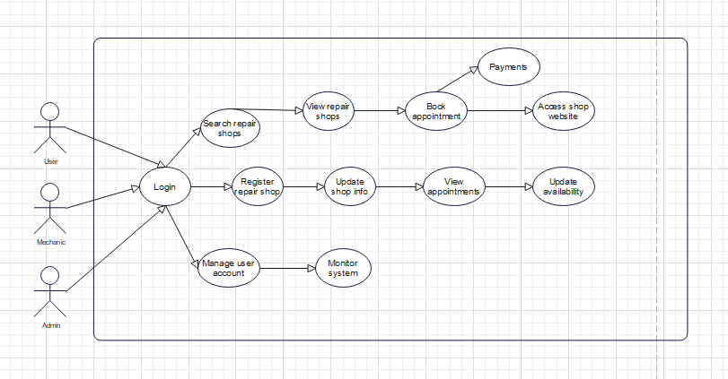
Use case diagram

Sequence Diagram:
- Displays the interactions between the different actors in the system over time.
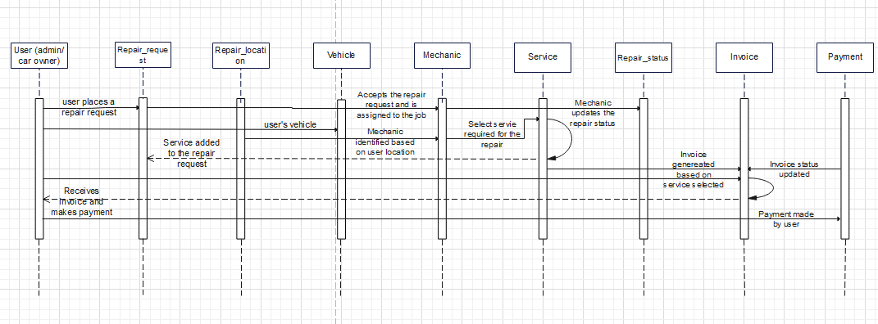
Sequence diagram

Class Diagram:
- Represents the classes in the system, such as User, Shop, Review, and their relationships.
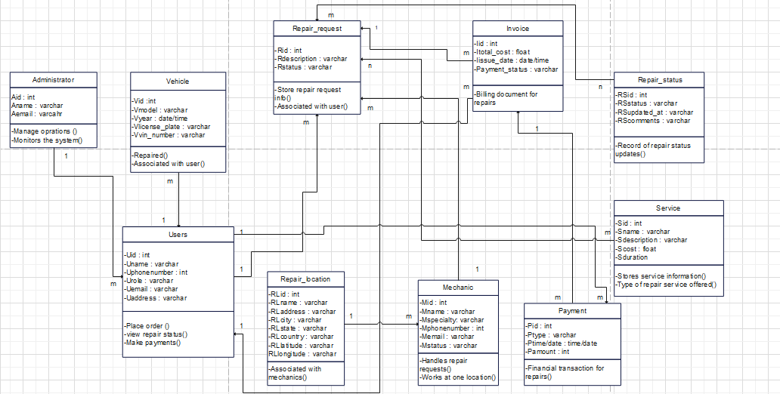
Class diagram

3.13.3 COMPONENTS OF THE SYSTEM
- Login Interface: A user-friendly login screen where users can enter their credentials to access their accounts.
- Search Interface: A map-based interface where users can input their location and filter their search for repair shops.
- Shop Listing Page: Displays information about car repair shops, including ratings, services, and website links.
- Admin Dashboard: A management interface for system administrators to oversee user accounts and shop information.

3.14 VARIOUS MODELS OF THE METHOD USED FOR DESIGN
3.14.1 DATA DICTIONARY
Description:
A data dictionary defines the data elements, their meanings, and how they are used in the car repair system.
After the analysis of the various entities, the data dictionary has to be established. It is about A table in which all the data are listed with precise details: N°, reference, significance, type And size. All these data result from the information collected during the interview and the Information retrieved.
Entries for the users table
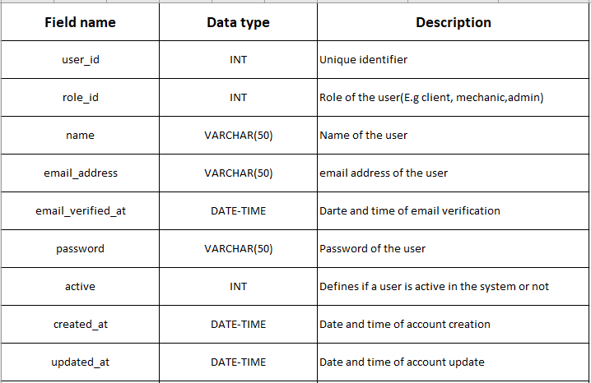
3.14.1.1 CONCEPTUAL DATA MODEL
This Data Model defines what the system contains. It is typically created by Business stakeholders and Data Architects.
The purpose is to organize scope and define business concepts and rules, its aimed at establishing the entities, their attributes, and their relationships. In this Data modeling level, there is hardly any detail available of the actual Database structure.
The 3 basic tenants of Data Model are:
Entity: A real-world object used when creating a database.
Attribute: Characteristics or properties of an entity
Relationship: Dependency or association between two entities

Characteristics of a conceptual data model
• Offers Organization-wide coverage of the business concepts.
• Developed independently of hardware specifications like data storage capacity, location or software specifications like DBMS vendor and technology. The focus is to represent data as a user will see it in the real world.
Conceptual data models known as Domain models create a common vocabulary for all stakeholders by establishing basic concepts and scope.
3.14.1.2 LOGICAL DATA MODEL (LDM)
LDM defines how the system should be implemented regardless of the DBMS.
This model is typically created by Data Architects and Business Analysts. The purpose is to develop technical map of rules and data structures. Logical data models add further information to the conceptual model elements.
It defines the structure of the data elements and set the relationships between them. The advantage of the Logical data model is to provide a foundation to form the base for the Physical model.
However, the modeling structure remains generic. At this Data Modeling level, no primary or secondary key is defined.
At this Data modeling level, you need to verify and adjust the connector details that were set earlier for relationships.
Characteristics of a Logical data model
• Describes data needs for a single project but could integrate with other logical data models base done the scope of the project.
• Designed and developed independently from the DBMS.
• Data attributes will have data types with exact precisions and length.
• Normalization processes to the model is applied typically till 3NF.
3.14.2 RULES TO MOVE FROM CDM TO DATA LDM
- Rule 1: Any entity becomes a table in which the attributes become columns. The identifier of the entity then constitutes the primary key of the table.
- Rule 2: An association of the type 1: n disappears and becomes a foreign key of the table of the side0:1 or 1:1 which refers to the primary key of the other table
- Rule 3: An association of the type n: n (that is which has positioned maximum cardinalities with “n”on the two sides of association) results in the creation of a relation of which the primary key is made up of the foreign keys referring the relations corresponding to the entities bound by association
- Rule 4: A binary association of type 1:1 is represented by a binary association of type 1: n. Except that the foreign key is seen imposing a constraint of iniquity in addition to one possible constraint of vacuity.
- Rule 5: Any non-association on the type 0: n can be seen as another table with primary key becoming all the foreign keys. The observation of the rules of passing from the CDM to the LDM enabled us to generate the following LDM. For our application, we can have the following LDM

3.15 SOFTWARE USED
Development and Design Tools:
- UML Tools: EdrawMax
- Database Management: MySQL
- Web Development: Visual Studio Code
- Prototyping: Figma
- Server : XAMPP Server
- Browser: Microsoft Edge
- Email testing tool: MailHog

3.16 PROGRAMMING LANGAUGES
Languages Used:
- Front-End: JavaScript
- Back-End: PHP

3.17 HARDWARE USED
For the implementation of this system I used a computer having the following Characteristics: • A laptop computer brand LENOVO
• Processor: Intel(R) Celeron(R) N4020 CPU @ 1.10GHz 1.10 GHz
• RAM: 4 Go
• Hard Disk: 250Go
• Operating System: Microsoft Windows 11

3.18 MODULES OF THE DESIGN SYSTEM
- User Management Module: Handles user account creation, login, and profile management.
- Search Module: Enables users to find car repair shops based on location and criteria.
- Shop Management Module: Allows shop owners to manage their shop's profile and respond to reviews.
- Review and Rating Module: Allows users to submit reviews and rate their experiences with repair shops.

3.19 PHYSICAL ORGANIZATION(STRUCTURE ) OF THE SYSTEM
Microservices Architecture:
- Front-End Service: Component serving the user interface.
- API Gateway: Entry point for client requests, routing them to appropriate microservices.
- User Service: Manages user data and authentication.
- Shop Service: Handles shop data and business logic.
- Review Service: Manages user feedback and ratings.

Database Layer:
- MSQL for structured data storage.

CHAPTER 4
RESULTS AND DISCUSSION
4.1 INTRODUCTION
This chapter presents the results of the developed car repair system. It focuses on the system's functionality, user experience, it’s design and how the components interact in the system.
4.2 RESULT
- System Functionality: Using print screens we will see how the different actors interact in the system.
- User Interface: We will see the layout , the map view, the search bar, the way shop details are presented and how friendly the interface is.
4.3 PRESENTATIONS OF SCENARIOS
Home page
This is the homepage where users can search for car repair shops using the search button using the shop’s name after entering the website’s link. Users can browse across the platform without needing to create an account.
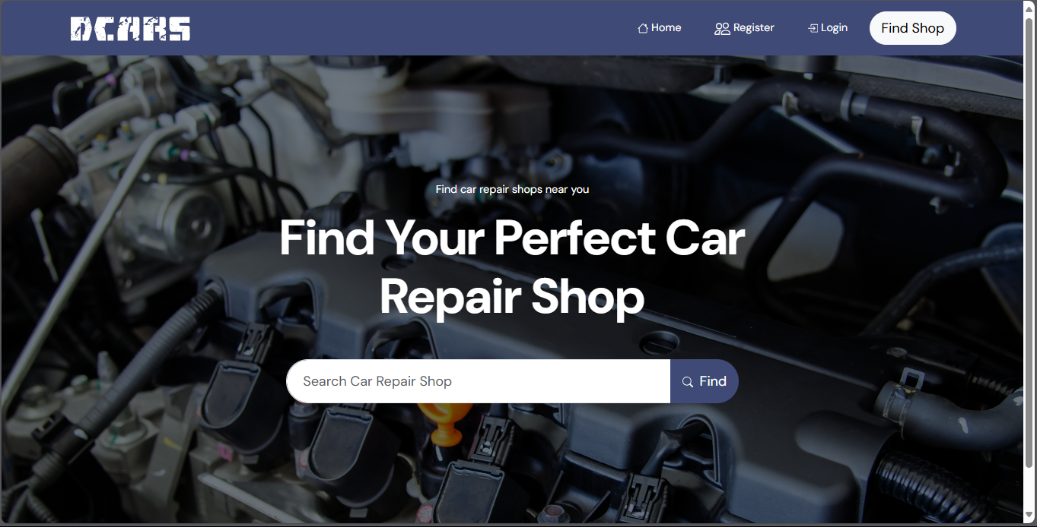

Login and registration forms
Registration is exclusively for mechanics who wish to list their services and don’t have a website to manage them. Login is both for mechanics and admins, only authorized administrators can log into the system.
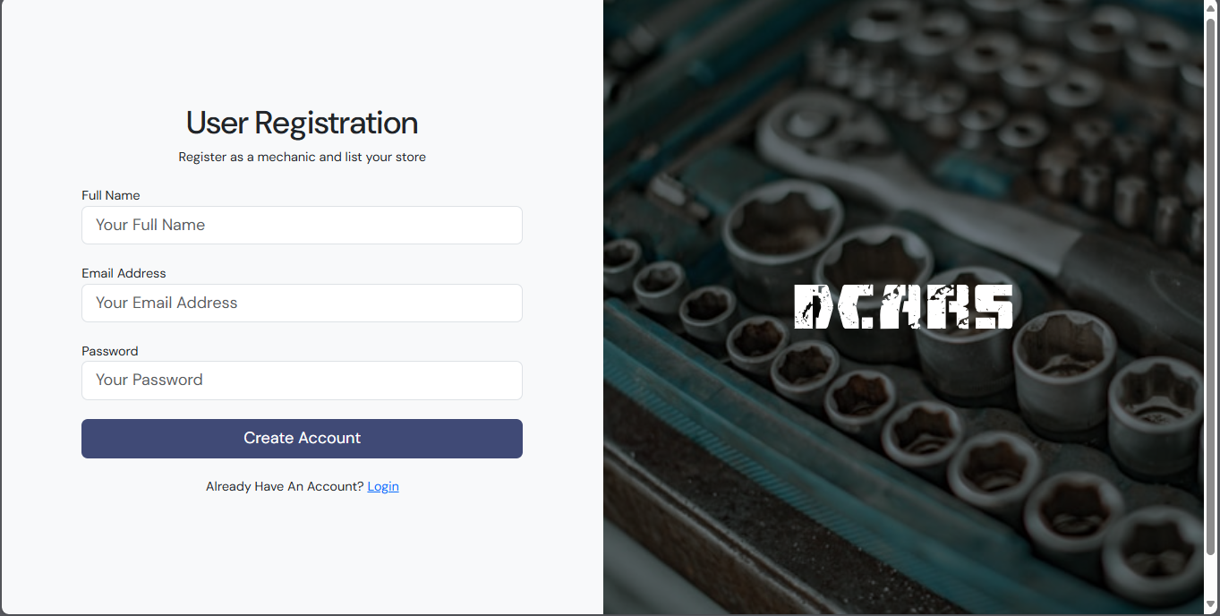
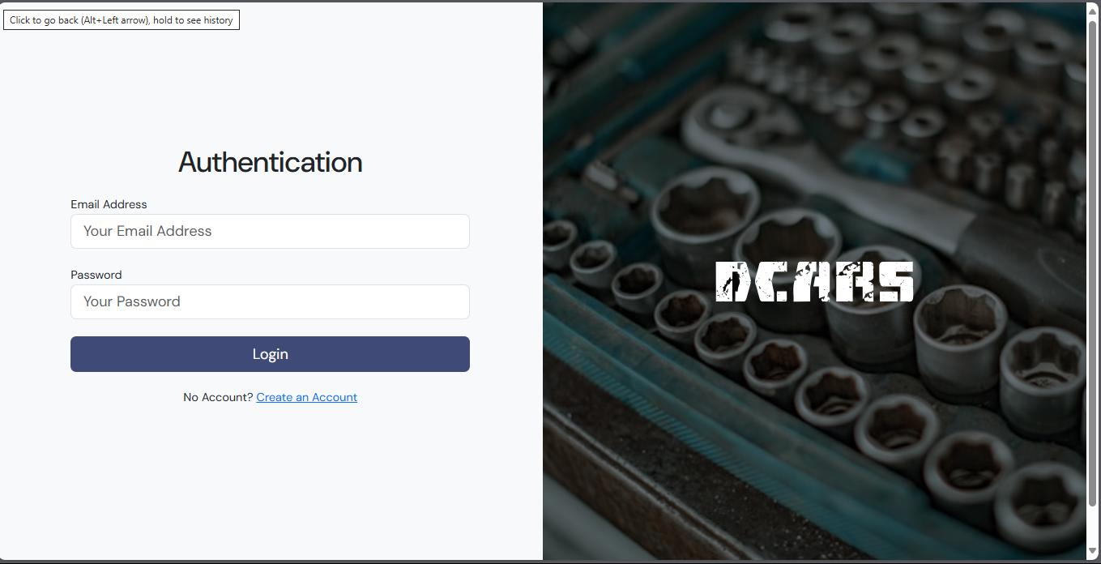

Below is an overview of where mechanics after creating their accounts, will receive a link for their email to be verified before completely accessing the system.
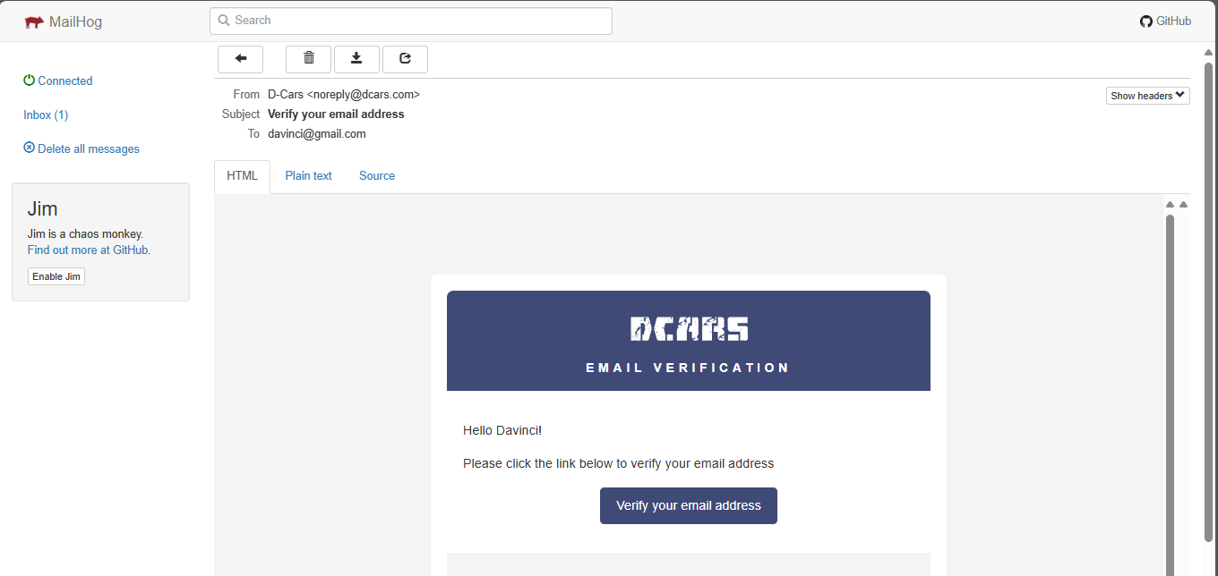

DASHBOARD
This is the overview of the admin dashboard that provides admins with the tools needed to effectively manage the system including user management and system settings.
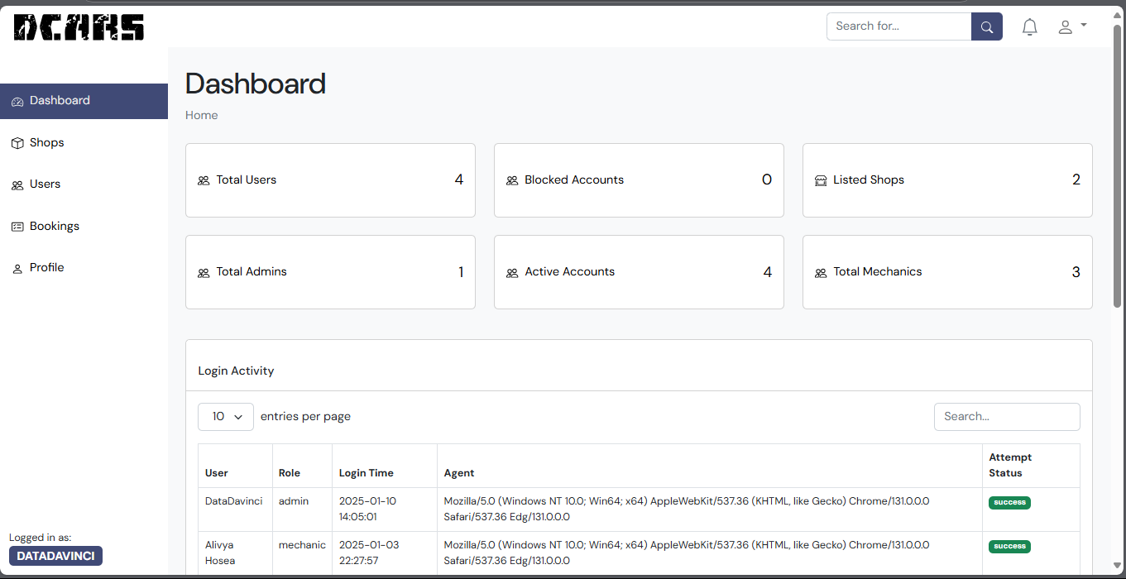
This is the dashboard for the mechanics which provides them with the tools to needed to manage their shops and track their services.
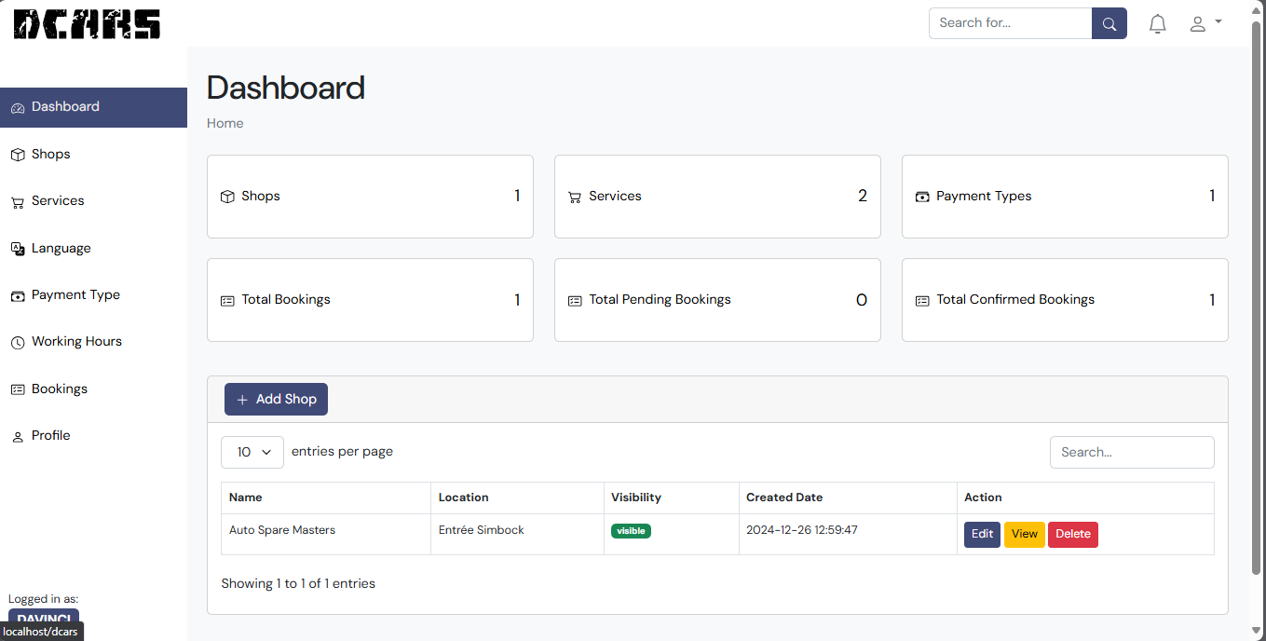

SHOPS
Below is the image of the interface users see after the clicked on the search button to find a shop. The available shops registered into the system alongside with their websites for shops having are shown.
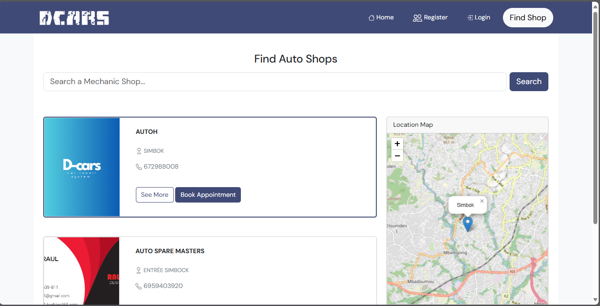

DATABASE
Below is the database for the system where all the information about the are stored.
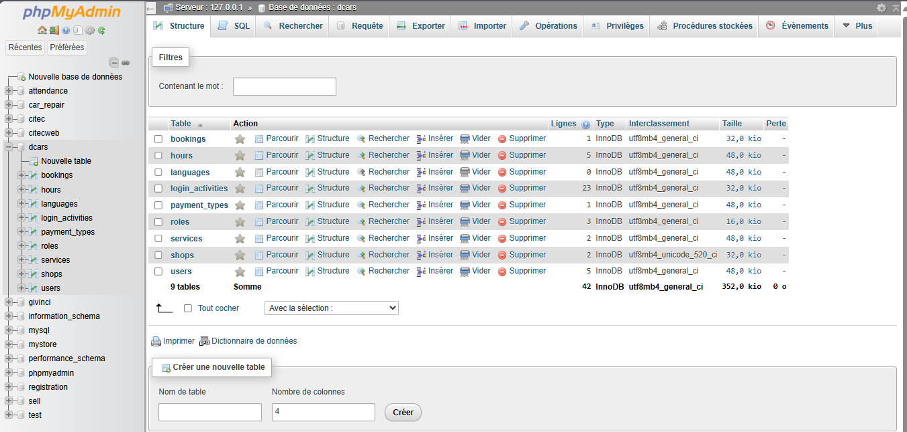

CHAPTER 5
CONCLUSION AND RECOMMENDATION
5.1 SUMMARY OF FINDINGS
This system successfully addresses the challenge of finding reliable repair shops based on location. By a comprehensive database of repair shops, and an intuitive user interface, the system empowers users to quickly and easily discover local mechanics and access their websites for more information.
5.2 DIFFICULTIES(LIMITATIONS) ENCOUNTERED
While the system is functional and user-friendly, some challenges arose:
- Data Accuracy: Maintaining a constantly accurate database of repair shop information proved to be an ongoing challenge. Ensuring up-to-date contact details, accurate locations, and consistent listings required careful attention.
- Programming: The complexity of this system made me encounter significant challenges which required me to undertake additional learning and self-study and also to reach out to my trainers for guidance and support.
- User Feedback: Gathering and incorporating user feedback is crucial, I identified areas for improvement, such as adding features for booking appointments or integrating customer reviews.

5.3 RECOMMENDATIONS
To enhance the system and address the limitations, I propose the following recommendations:
- Data Management: Implementing automated data updates from reliable sources, integrating with external databases (like vehicle registration data), and enabling user-driven validation mechanisms could significantly improve data accuracy.
- User Experience: Adding features like appointment scheduling, customer review integration, or car maintenance reminders could enhance user experience and make the system even more valuable.
- Future Development: Expanding the system to cover a wider geographical area, integrating with online payment platforms, or offering advanced filtering options (specializations, pricing ranges) could further enhance its functionality and appeal.

CONCLUSION
The development of this car repair system marks a significant step towards simplifying the process of finding and connecting with local mechanics. By combining mechanics location data with a comprehensive database of repair shops, the system successfully addresses a common challenge faced by car owners: finding reliable and convenient service options.

